**Steps: To Create an API for Barcode Scanning:-**

**Tools Needed to be installed:**

**1) Visual Studio Code**

**2) Xampp Server**

**3) Postman**

**Step 1:**

Download and Install Visual studio code editor for writing code and use Git Bash or CMD terminal for installing laravel. In my case i had used Git Bash terminal. Now press CNTRL+SHIFT+` or select dropdown Terminal-New Terminal to open terminal.

**Step2:**

Install Xampp server and start Apache and MySQL Module. Also Create folder inside Xampp-> htdocs->Laravel-Barcode. And open that folder in Visual Studio code. You will see project folder you ready to install. In my case i have folder path C:\xampp\htdocs\Laravel-Barcode.

**Step 3**:

Now I am going to install laravel latest version with composer, packages and generate key php artisan key so I am going to run this command below.

composer create-project --prefer-dist laravel/laravel barcode

**Step 4:**

- Execute command:

- $ dir

You will see directory folder barcode.

Enter cd C:/xampp/htdocs/Laravel-Barcode/barcode command

Then go to main install file path in folder and check composer,PHP & Laravel version install.

It will be something like this:

- $ composer -V

Composer version 2.2.9 2022-03-15 22:13:37

-$ php -v

PHP 8.1.2 (cli) (built: Jan 19 2022 10:18:23) (ZTS Visual C++ 2

019 x64)

Copyright (c) The PHP Group

Zend Engine v4.1.2, Copyright (c) Zend Technologies

-$ php artisan -V

Laravel Framework 9.7.0

**Step 5:**

To generate barcode run this command

- composer require picqer/php-barcode-generator

**Step 6:**

In visual studio code editor open this project and make following changes:-

First make changes in .env file add database name:

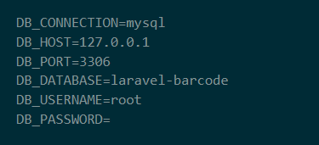

Also you need to create controller , migration and model files by executing this command:

-php artisan make:model Barcode –mcr

so this 3 files will be created.

So make changes in files according to screenshots.

1) Controller File:

Go to folder app/Http/Controllers/ and add this BarcodeController.php file.

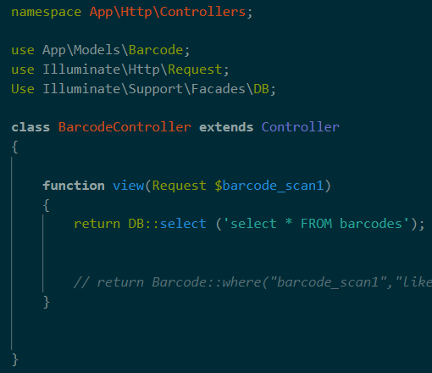

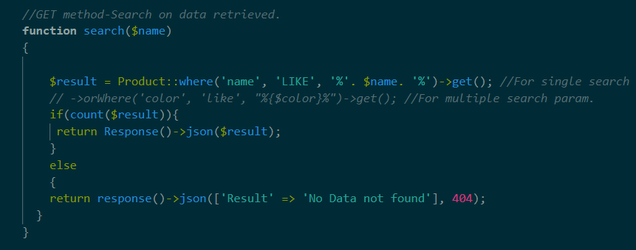

2) Migration File:

Go to database/migrations/ folder then in 2022_04_07_142216_create_barcodes_table.php file make this changes.

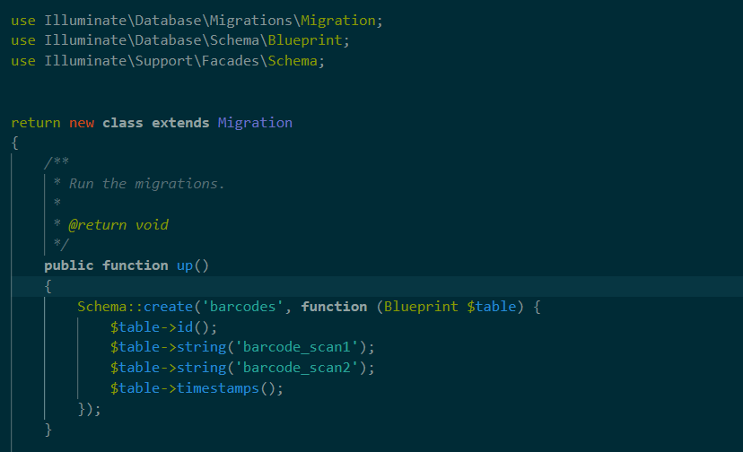

Now execute this command:

php artisan migrate

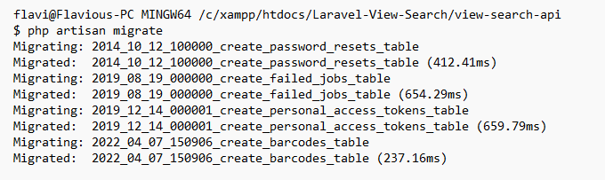

Database-All Tables will be created:

i.e barcodes table is inserted created here.

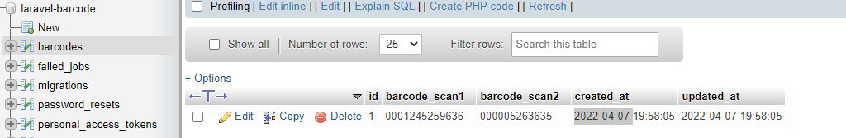

3) Model file:

Now Go to app/Models/ folder and then in Barcode.php file make this changes:

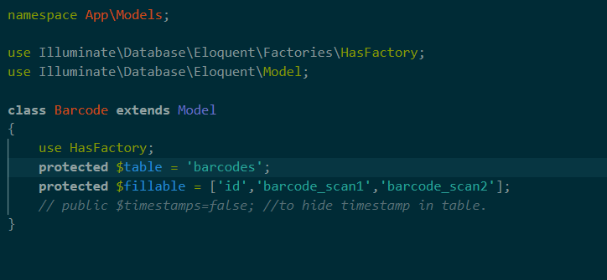

The next files is to be edited are:

1. Web file:

Go to routes/ folder and then to web.php & make this changes as shown below:

We have add Route as shown below in web.php to run application.

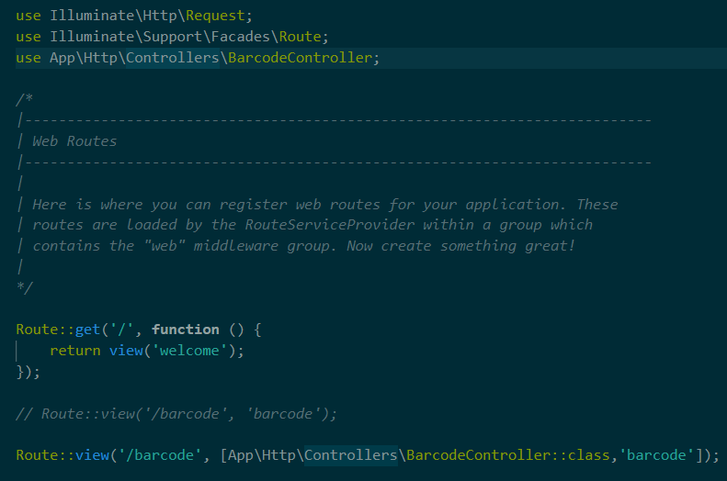

We have to start Laravel Development Server by executing command

-php artisan serve

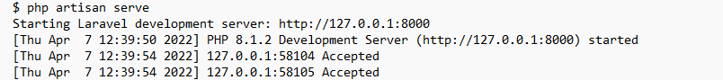

-Now Run this url to check barcode for scanning in browser:

-http://127.0.0.1:8000/barcode

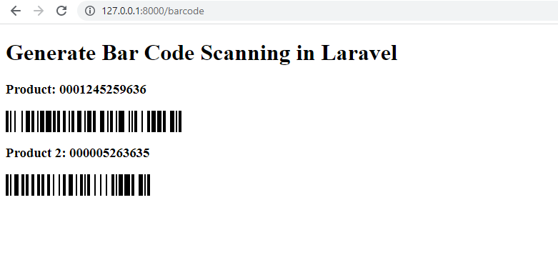

Barcode after Scanning:

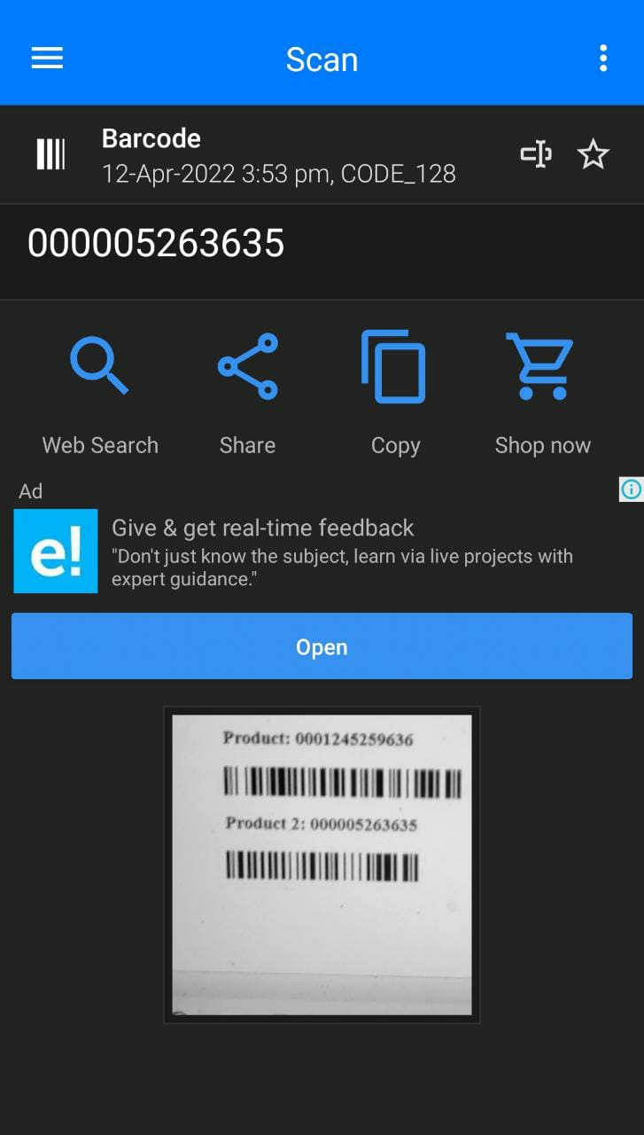

2) api file:

Go to routes/ folder and then to api.php make this changes as shown below:

Here we add a Route by get method to retrieve data from database and show in api.

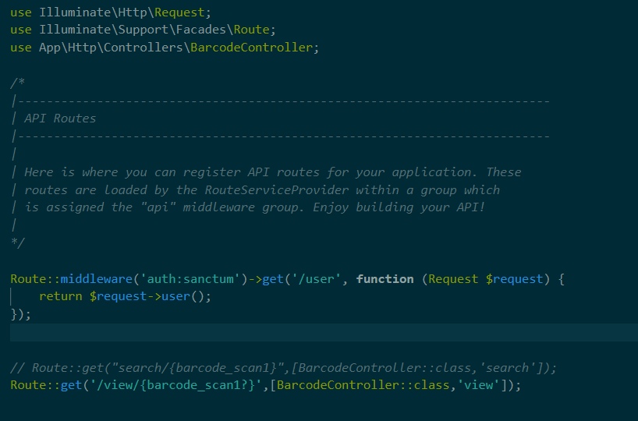

**Step 7:**

-Last step is postman tool we select method GET and type-No Auth , send Request by get method and url-http://127.0.0.1:8000/api/view/1 by clicking on send will give you data from database: laravel-barcode i.e table- barcodes inside the Body.

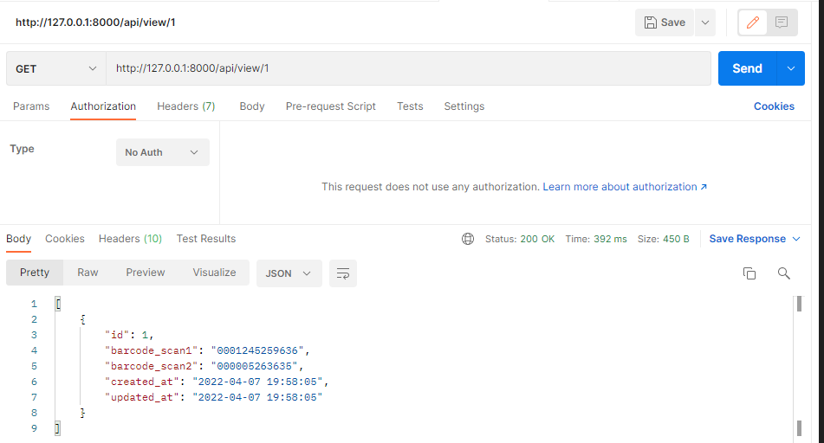

So we have created an API for Barcode Scanning.